MOTHER THERESA INSTITUTE OF ENGINEERING & TECHNOLOGY
(Approved by AICTE, Affiliated to Jawaharlal Technological University Anantapuram)
Melumoi Post, PALAMANER – 517408

National Service Scheme-MTIET

From:
Mr. N. V. KISHORE KUMAR _{M.Tech}
Assistant Professor
EEE Department

REFF NO: MTIET/NSS-MTIET/UBA/COVERING LETTER/2020-21 Date: - 08-01-2021

To
The Principal Sir
MTIET
Sub: - MTIET – NSS-MTIET - REQUEST FOR PERMISSION TO ORGANIZE “VILLAGE SURVEY IN MELUMOI” – Reg.
Sir,
As a part of UBA activities, the NSS-MTIET was planning to conduct “village house hold survey” in MELUMOY village. In connection to the above program I request you to give permission to carry out program on 12-01-2021 along with the faculty & students. This is for your kind perusal.
THANKING YOU

Yours faithfully

N.V.KISHORE KUMAR,
CO-ORDINATOR, NSS - MTIET

MOTHER THERESA INSTITUTE OF ENGINEERING & TECHNOLOGY
(Approved by AICTE, Affiliated to Jawaharlal Technological University Anantapuram)
Melumoi Post, PALAMANER – 517408
National Service Scheme-MTIET

CIRCULAR

REFF NO: MTIET/NSS-MTIET/UBA/CIRCULAR/2020-21 Date: - 09-01-2021

As a part of UBA ACTIVITIES, the NSS-MTIET is going to conduct “village house hold survey” in MELUMOI village. In connection to the above program I request the faculty, students & NSS volunteers to register the names with NSS department coordinators to participate in the program on 12-01-2021.

Circular to all staff members
Circular to all class rooms
Copy to notice board
Copy to file N.V.KISHORE KUMAR,
CO-ORDINATOR, NSS - MTIET

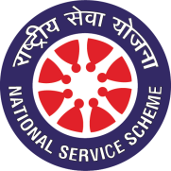
MOTHER THERESA INSTITUTE OF ENGINEERING & TECHNOLOGY
(Approved by AICTE, Affiliated to Jawaharlal Technological University Anantapuram)
Melumoi Post, PALAMANER – 517408

National Service Scheme-MTIET

REPORT ON
“VILLAGE HOUSE HOLD SURVEY, IN MELUMOI”
Organized by NSS-MTIET under UBA on 12/01/2021

As a part of UNNAT BHARAT ABHIYAN program, The NSS cell of MOTHER THERESA INSTITUTE OF ENGINEERING & TECHNOLOGY has organized VILLAGE HOUSE HOLD SURVEY in one of the adopted village under UBA namely MELUMOI village.
The program was started at 10:30 AM in the morning and a brief introduction is given to the students & NSS volunteers regarding the program and distributed the house hold survey form template issued by the UBA, where 144 students & NSS volunteers actively participated along with all the faculty members who surveyed and collected the household data as per the requirement in entire village.
As a part of the program the volunteers has noted what are the main problems in the village. The sarpanch of the village appreciated with the program and provided the necessary facilities for the volunteers. The program was carried out through out day till 5:00 PM.

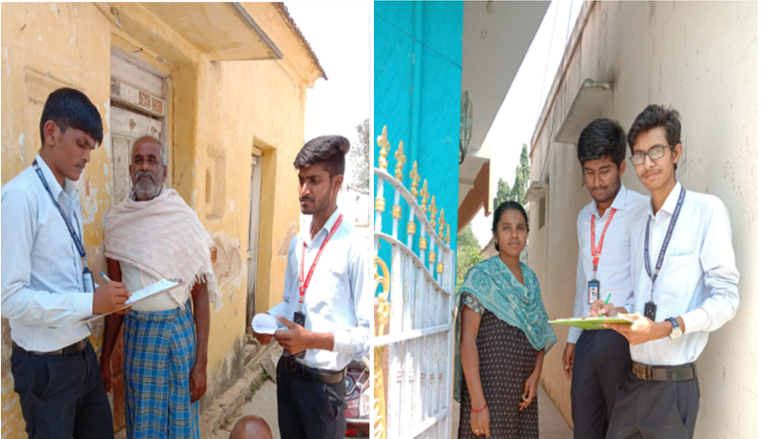
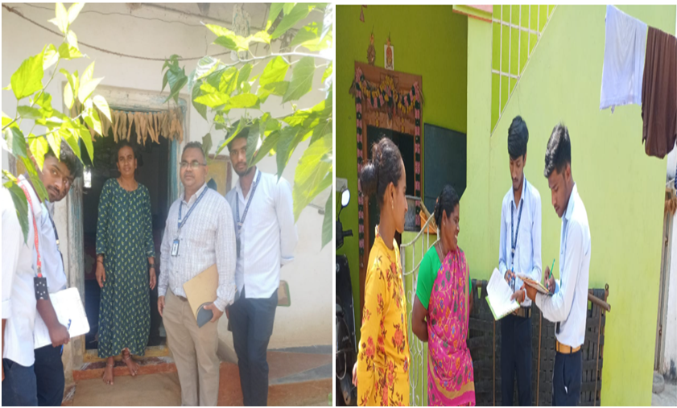
STUDENTS COLLECTING HOUSE HOLD DATA IN ADOPTED VILLAGE @ “VILLAGE HOUSE HOLD SURVEY, IN MELUMOI” – 20/01/2021

N.V.KISHORE KUMAR,
CO-ORDINATOR, NSS - MTIET

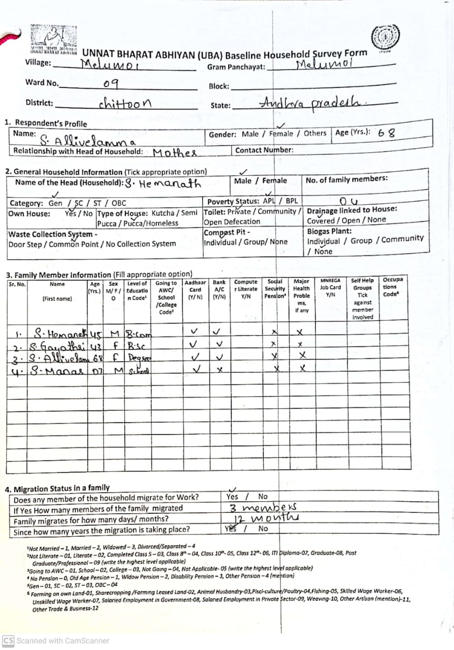
HOUSE HOLD SURVEY FORM @ “VILLAGE HOUSE HOLD SURVEY, IN MELUMOI” – 20/01/2021

HOUSE HOLD SURVEY FORM @ “VILLAGE HOUSE HOLD SURVEY, IN MELUMOI” – 20/01/2021

MOTHER THERESA INSTITUTE OF ENGINEERING & TECHNOLOGY
(Approved by AICTE, Affiliated to Jawaharlal Technological University Anantapuram)
Melumoi Post, PALAMANER – 517408
National Service Scheme-MTIET
“VILLAGE HOUSE HOLD SURVEY, IN MELUMOI”
Organized by NSS-MTIET under UBA on 12/01/2021
PARTICIPANTS LIST
SL.NO | NAME OF THE PARTICIPANT
 | A HARI PRIYA
 | A MAHESH
 | B AADARSH
 | B BHARGAVI
 | B MOHANA KUMARI
 | B YASWANTH
 | B.LEELA MANOHAR
 | BYRIGANIPALLI MOUNIKA
 | C BHASKAR REDDY
 | C S CHAITHANYA
 | CHENNURU NANDINI
 | CHINTHAPARTHI JOSHITHA
 | DHARMAVARAM NANDINI
 | ENDAPALLE PRATHAP
 | ERUVARAM SRAVANI
 | G VENUGOPAL
 | G.POORNIMA
 | GADDAPARA SRAVANI
 | GELASAM RAJESWARI
 | J M JAFFAR
 | K KALYAN KUMAR
 | K SARATH KUMAR
 | K.MAHESH
 | K.RAJKUMAR
 | KOMMAIRI MALLIKARJUNA
 | KOTHAPAPANNAGARU MUNI ARAVIND
 | KUPPAM CHARAN KUMAR REDDY
 | LAKKUNTA KUSUMA
 | MANGARAJU RANA PRATHAP
 | MANOJ M
 | MEDASANI PAVAN KUMAR
 | MEESALA ROZ LUTHER
 | MUCHUKOTA HARISH
 | NEELA JAYANTHI
 | NETHIVALLA VINAY
 | P.PRASANTH
 | PALETI ASWINI
 | PATAN MOHAMMAD KHAN
 | PEDDA SONNAPPAGARI REDDY SEKHAR
 | POOJARI MALLIKARJUNA
 | R.IRFAN KHAN
 | S.RAGHA BHARGAV
 | S R RAMYA
 | SUBBARAYAPPAGARI DIVYASREE
 | T.SAMBHAVI
 | TANAKANTI VANI
 | THOTI SUNILKUMAR
 | V.NAGENDRA CHARY
 | D HARIKA
 | BHEEMINENI HARSHAVARDHAN
 | CHINTHA KALYANKUMAR
 | CR PAVANKUMAR
 | K OMNATH
 | K TEJO RANI
 | KONDREDDYGARI SIREESHA
 | M LAKSHMAIAH
 | M RAMAIAH
 | P INDIRA
 | P MONIKA
 | RAPAKA STEPHEN BABU
 | A GAYATHRI
 | AMENATHAM BHARATH KUMAR
 | B SURESH REDDY
 | BUUKKE THARUN RAJ NAIK
 | CHINNA REDDY HARISH
 | CHINTAMANI PAVANI
 | GUDISA NEETHA
 | GANDLA PRASANTH
 | J DIVYA
 | K BHARGAV
 | K NITHYA SRI
 | KUMMARA RAVALI
 | M A SUHANULLA KHAN
 | MANTHRA MANASA
 | NARAYANAREDDIGARI SREE LATHA
 | ORSU PRAVEEN KUMAR
 | PASUPULETI PURUSHOTHAM
 | PENUBAAKU BALAIAH
 | R LAHARI
 | S GOUSE BASHA
 | S PALLAVI
 | SHAIK NOOR MAHAMMAD
 | SHAIK RIHAN
 | THOTHUKA SRAVANI
 | V THARUN
 | CHANDRAGIRI RAVINDRA
 | CHINTALA SANDEEP
 | CHITTEM VAMSI
 | D DHANUSH GOWDU
 | DAYYALA SHIVA
 | DURJATI GOPAL KRISHNA
 | ETHOTI NAVEENKUMARREDDY
 | G JASWANTH
 | GAGGUTURI FAAZIL
 | GALIVEETI KEERTHANA
 | GANUMUKKALA PRASAD
 | GOLLA GOWTHAM
 | GOLLA SIREESHA
 | JARUGUMALLI PRASANTH
 | JUTTU SAI THARUN
 | K TEJA KUMAR
 | KALIGIRI AJITH
 | KATTUBADI ARUNA
 | KAVALI KEERTHI REDDY
 | KAVALI SASIKALA
 | KAYALA MANORANJITHA
 | KOTHOLLA DIVYA
 | KRISHNAREDDIGARI ANUSHA
 | KUMMARA ROHINI
 | MANCHINTI GANESH
 | MUNEPPAGARI BHAVANI SANKAR
 | NATARAJ MADHAVA
 | P MENAKA
 | PENUBALA PAVAN
 | PULIMI GOWTHAM
 | S AFSANA
 | S AKRAM
 | SHAIK AMEER BASHA
 | A M PRAHLLADA
 | A MANOJ VAMSI
 | ABBOLLA RAVI TEJA
 | AYYALA THANUSHA
 | BISATI CHARITHRA
 | C TEJA
 | CHEEMIREDDYGARI ARUNKUMAR REDDY
 | CHIRRA SIVA SANKAR
 | CHITIKI BABU REDDY
 | G DHARANI
 | GAJULA RUPESH
 | GAJULA SAIBHANU
 | GANGIREDDY CHARAN REDDY
 | GONUGUNTLA MAHESH
 | J HARSHITHA
 | K NAVEEN KUMAR
 | K PAVAN
 | K ROHITH
 | K SAI RACHANA
 | K VANDANA
 | K VANI
 | KADAM YERRAMALLAIAH
 | KAMIREDDI ALEKHYA
 | KARISIMANGALAM SANTHOSH
 | KOKKINTI DEVINAGACHANDANA
 | KURABA JAGADISH

N.V.KISHORE KUMAR,
CO-ORDINATOR, NSS - MTIET

