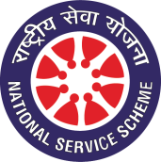
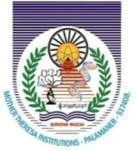
MOTHER THERESA INSTITUTE OF ENGINEERING & TECHNOLOGY
(Approved by AICTE, Affiliated to Jawaharlal Technological University Anantapuram)
Melumoi Post, PALAMANER – 517408

National Service Scheme-MTIET

From:
Mr. N. V. KISHORE KUMAR _{M.Tech}
Assistant Professor
EEE Department

REFF NO: MTIET/NSS-MTIET/UBA/COVERING LETTER/2020-21 Date:- 08-12-2020

To
The Principal Sir
MTIET
Sub: - MTIET – NSS-MTIET - REQUEST FOR PERMISSION TO CONDUCT “GRAM SABHA IN MELUMOI” – Reg.
Sir,
As a part of UBA activities, the NSS-MTIET was planning to conduct “gram Sabah” in MELUMOI village. In connection to the above program I request you to give permission to carry out program on 11-12-2020 along with the faculty & students. This is for your kind perusal.
THANKING YOU

Yours faithfully

N.V.KISHORE KUMAR,
CO-ORDINATOR, NSS - MTIET

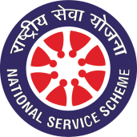
MOTHER THERESA INSTITUTE OF ENGINEERING & TECHNOLOGY
(Approved by AICTE, Affiliated to Jawaharlal Technological University Anantapuram)
Melumoi Post, PALAMANER – 517408
National Service Scheme-MTIET

CIRCULAR

REFF NO: MTIET/NSS-MTIET/UBA/CIRCULAR/2020-21 Date: - 09-12-2020

As a part of UBA ACTIVITIES, the NSS-MTIET is going to conduct “gram Sabah” in MELUMOI village. In connection to the above program I request the faculty, students & NSS volunteers to register the names with NSS department coordinators to participate in the program on 11-12-2020.

Circular to all staff members
Circular to all class rooms
Copy to notice board
Copy to file N.V.KISHORE KUMAR,
CO-ORDINATOR, NSS - MTIET

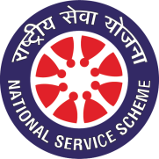
MOTHER THERESA INSTITUTE OF ENGINEERING & TECHNOLOGY
(Approved by AICTE, Affiliated to Jawaharlal Technological University Anantapuram)
Melumoi Post, PALAMANER – 517408
National Service Scheme-MTIET
REPORT ON
“GRAM SABAH EVENT, IN MELUMOI”
Organized by NSS-MTIET under UBA on 11/12/2020

As a part of UNNAT BHARAT ABHIYAN program, The NSS cell of MOTHER THERESA INSTITUTE OF ENGINEERING & TECHNOLOGY has conducted GRAM SABAH in one of the adopted village under UBA namely MELUMOI village.
The program was started at 10:30 AM in the morning and UBA Faculty co-coordinators of our college & sarpanch of the MELUMOI village have organized a gram Sabah in the village to explain about the Moto of the UBA program to the villagers and activities that are going to organize in the village under the program.
The faculty members are undergone to a great discussion with the villagers to identify the problems in the village that can be solved technically. In this program 10 faculty coordinators & 79 students are actively participated to provide necessary requirements for the meeting.

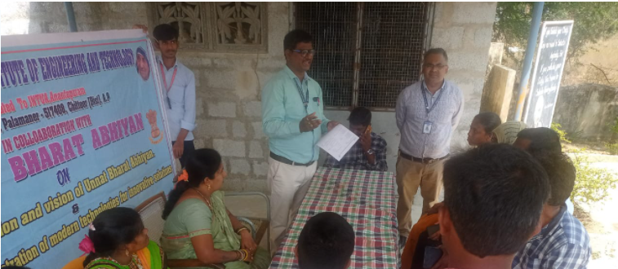
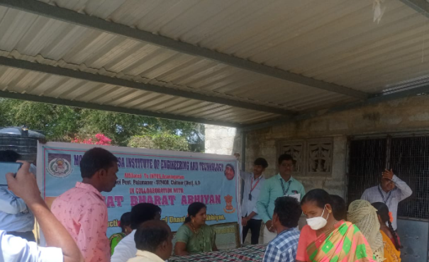
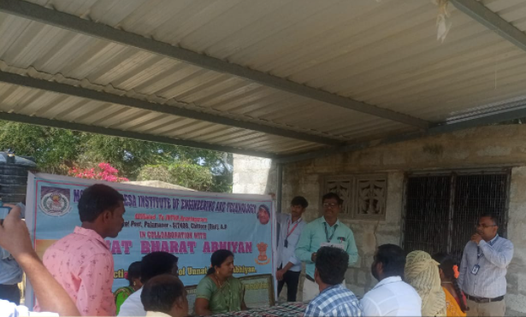
FACULTY CO-ORDINATORS INTACTION WITH THE VILLAGERS OF MELUMOI @ GRAMSABHA – 11/12/2020

N.V.KISHORE KUMAR, CO-ORDINATOR, NSS - MTIET

MOTHER THERESA INSTITUTE OF ENGINEERING & TECHNOLOGY
(Approved by AICTE, Affiliated to Jawaharlal Technological University Anantapuram)
Melumoi Post, PALAMANER – 517408
National Service Scheme-MTIET
“GRAM SABAH EVENT, IN MELUMOI”
Organized by NSS-MTIET under UBA on 11/12/2020
PARTICIPANTS LIST
SL.NO | NAME OF THE PARTICIPANT
 | ALLA DIVYA SREE
 | AMBURI RAMYA
 | APPIREDDIGARI RAJASEKHAR REDDY
 | BANDREVULA JANARDHAN
 | BAYUMAUDI SANDHYA
 | BHOGAM ANUSHA
 | BOORUSU CHARAN KUMAR
 | CHIRUTHANURU NIKHIL BHARADWAZ
 | CHITIMIREDDIGARI ABHISNEHA
 | DASANI SAI KARTHIK REDDY
 | DHARA RAVIGARI SURYA KIRAN
 | G MEGHAMALA
 | G SASI KUMAR
 | G VAMSIKRISHNA
 | KANNAREDDIGARI VENKATA LAKSHMI
 | KOLAR R KUSUMA
 | KONDAGALLA RAJAGOPAL
 | KUMMAROLLA MADHAVI
 | KUNA R SURYA
 | M MOUNIKA
 | M R MOUNIKA
 | MANIKESAVULU MOUNIKA
 | MATHALAM SWATHI
 | MUTYALA REDDY PAVAN
 | N BHARATHI
 | NAKKALA SATISH KUMAR REDDY
 | NANJEGOUNIVARI SILPA
 | NUTHANAKALVA SAI SUSMITHA
 | P JEEVITHA
 | PAGADALA JAYARAM
 | PARAMATA MANJULA
 | PATHRIVALLA NAVEEN
 | RAMAIAHGARI MADHAVA REDDY
 | RANGASWAMY AISWARYA
 | S A NEELUFAR
 | S BINDHU
 | S NITHISH CHANDRA
 | S SALEEM JAVEED
 | SANGISETTY SAI VIKAS
 | SHAIK MOHAMMED ALI
 | SUBBARAYAPPAGARI BHAVYASREE
 | THIMMIREDDIGARI SIREESHA
 | THOTI MOHAN
 | THOTI VINOD BABU
 | TIRUPATHI SREELEKHA
 | VEERA RAGHAVULA NAVEEN KUMAR
 | Y SARATH KUMAR REDDY
 | ANAGONDI RAJESH
 | B G MADHAVI
 | BELUDURI VIDYANANDA
 | CHITTIMOORI PURUSHOTHAM
 | G NAGARAJA
 | G PALLAVI
 | M SHAFFI
 | MUDEA REKHA
 | NULIVEEDU SANDEEP KUMAR
 | PEDDAKOTLA MURALI
 | REDDIVARI NAVEEN REDDY
 | T ESWARAIAH
 | VADDI MALLEESWARI
 | A HARI PRIYA
 | A MAHESH
 | B AADARSH
 | B BHARGAVI
 | B MOHANA KUMARI
 | B YASWANTH
 | B.LEELA MANOHAR
 | BYRIGANIPALLI MOUNIKA
 | C BHASKAR REDDY
 | C S CHAITHANYA
 | CHENNURU NANDINI
 | CHINTHAPARTHI JOSHITHA
 | DHARMAVARAM NANDINI
 | ENDAPALLE PRATHAP
 | ERUVARAM SRAVANI
 | G VENUGOPAL
 | G.POORNIMA
 | GADDAPARA SRAVANI
 | GELASAM RAJESWARI

N.V.KISHORE KUMAR,
CO-ORDINATOR, NSS - MTIET

